GAYATRI VIDYA PARISHAD COLLEGE OF ENGINEERING FOR WOMEN

(Approved by AICTE NEW Delhi, Affiliated to JNTUK Kakinada)

[Accredited by National Board of Accreditation (NBA) for CSE, ECE, IT – Valid from 2019-20 to 2021-22]

Kommadhi, Madhurawada, Visakhapatnam -530048

DEPARTMENT OF COMPUTER SCIENCE AND ENGINEERING

**STUDENT ACHIEVEMENT MAINTENANCE SYSTEM**

Submitted by

BATCH NUMBER : TB2

18JG1A0576-PILAKA RUCHITHA REDDY

18JG1A05A0-VARANASI SHUKESHINI

18JG1A0584-SAI VINEELA PORANKI

19JG5A0506-SHAIK ZAHEERA FARHIN

Under the Guidance of

**V.GOWTAMI ANNAPURNA**

Assistant Professor

(Signature of Guide) (Signature of Co-ordinator)

Students Achievement Maintenance System

# INDEX:

1. Abstract ------------------------------------------------------------------1
2. Introduction ---------------------------------------------------------------1
3. Requirements ---------------------------------------------------------------1
4. Design ---------------------------------------------------------------------1
   1. Tables-----------------------------------------------1
   2. Code ------------------------------------------------1
5. Results ---------------------------------------------------------------------1
6. Conclusion -----------------------------------------------------------------1
7. References -----------------------------------------------------------------1

# 1.Abstract:

Generally campus recruitment is the process by which a company recruit students who are about to graduate ,by gathering their information from colleges and they usually conduct various rounds of testing to filter the students which is a time consuming process.So this project is a technical way to provide all the necessary information required for recruitment to the companies online through a web-based application which would help them to choose proficient students and conduct required rounds only to them hence saving their time and making their work more easier.Thus the main objective of this project is to equip a student achievement tracking webapp that would store all the academic related details and additional achievements achieved by the students by the use of **django** which is a high level Python Web framework.

It is an internet based web application that provides background on tracking about each individual student.The information covers all the student details,academic qualifications and also their additional achievements such as certifications,workshops,min-projects,job internships etc along with their proofs.The students can upload,view and edit only their individual profile whereas the organization members and companies can have the view access to every student details.

**MySQL database** is used to maintain the database which stores the information of the registered students, faculty and companies.

Benefits:

This project saves the time and also reduces the workload of companies during campus drive, besides it can be beneficial for the organization members by helping them to track the performance and achievements of students. It benefits the educational institutions by reducing the complexity involved while gathering the entire data of each and every student.

# 2. INTRODUCTION:

**Existing System:**

In the existing system, the organization members collect all the student data required for campus drive manually and store them .And the companies need to visit the campuses inorder to collect the information of students from the organization members .This process consumes a lot of time and effort.In this system, all the information is stored in records which is difficult to modify, search or delete.

Disadvantages:

* Time Consuming
* Less Efficient, more manual work required.

**Proposed System:**

The proposed system is an internet based system in which information is accurate and no worry of data misplacement. All the information stored in the database is easy to search, modify or delete. There is no need for the organization members to collect the data manually and the companies need not visit the campuses to collect the data, they can easily access the information from anywhere and they can even filter the students based on their performances.Thus it saves a lot of time and effort.

Advantages.

* Provides a simpler method to collect and access the information of students.
* Provides an easy way to filter students during campus drives.
* Certifications of students can also be downloaded by the companies or organization members in order to maintain a copy of them.

**Modules:**

Student:

Student need to give valid username and password to enter into the application. Students can upload their personal, academic data and also the certification documents. They can also view and modify the data uploaded by them.

Faculty:

Faculty need to give valid username and password to enter into the application. Faculty can view the list of students and the details and documents uploaded by each and every student.

Company:

Company member need to give valid username and password to enter into the application. Faculty can view the list of students and the details and documents uploaded by each and every student.

This Project uses **django** framework for web development .HTML,CSS are used for front end. For Backend python language is used.

**DJANGO:**

* It is a high level python framework for web development.
* Elegant system for mapping URLs to python code
* Generic view to handle common requests.
* Clean, powerful template language.
* It has components for user authentication.

**Creating a project:**

django –admin startproject SATP

**Creating an app within a project directory:**

python manage.py startapp student

**XAMPP:**

xampp stack of software is an open-source localhost server providing a number of functionalities through the package of software it contains. The software, which is part of XAMPP is started/stopped using the XAMPP Control Panel. Important functionality provided by XAMPP is the creation of the MySQL database. This is done by using phpMyAdmin.

**Creating MySQL Database with XAMPP:**

1- Navigate to XAMPP in your system or simply launch it by clicking the XAMPP icon for Creating MySQL Database . The Control Panel is now visible and can be used to initiate or halt the working of any module.

2- Click on the "Start" button corresponding to Apache and MySQL modules.

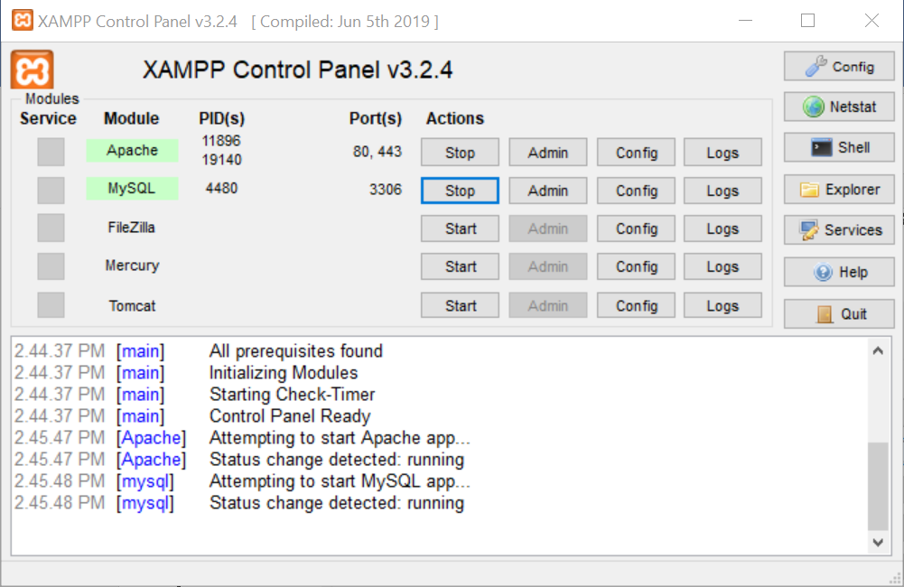

3- Now click on the "Admin" button corresponding to the MySQL module. This automatically redirects the user to a web browser to the following address-

**http://localhost/phpmyadmin**

MySQL is the most popular Open Source Relational SQL database management system. MySQL is one of the best RDBMS being used for developing web-based software applications.

MySQL is a fast, easy-to-use RDBMS being used for many small and big businesses

MySQL supports large databases, up to 50 million rows or more in a table. The default file size limit for a table is 4GB, but you can increase this (if your operating system can handle it) to a theoretical limit of 8 million terabytes (TB). MySQL is customizable

**Frontend:**

HTML stands for Hyper Text Markup Language. It is the standard markup language for creating web pages. It describes the structure of a web page. It consist of a series of elements.HTML elements tell the browser how to display the content.

CSS stands for cascading style sheets. It is used to format the layout of a webpage. With CSS, you can control the colour, font, the size of text, the spacing between elements, how elements are positioned and laid out, what background images or background colours are to be used, different displays for different devices and screen sizes, and much more!

# 3.REQUIREMENTS:

3.1 HARDWARE REQUIREMENTS:

**Processors:** Intel® Core™ i3 processor(4GB RAM)

**Operating systems:**  Windows10

3.2 SOFTWARE REQUIREMENTS:

**Programming language:** Python 3.6.8

**Framework:**  Django 3.0.1

**Server :**  XAMPP 7.4.8

**Text editor:**  Sublime

**Database:** MYSQL

# 4.DESIGN:

**TABLES:**

**Database_name:** student

**Table1:**

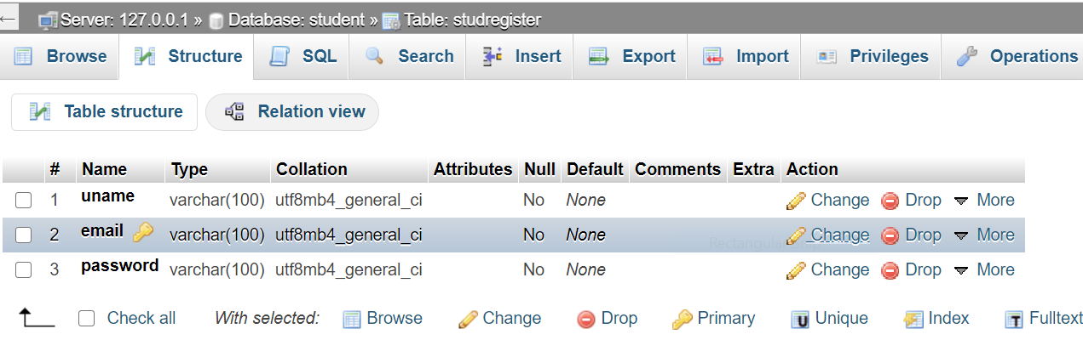

**Table2:**

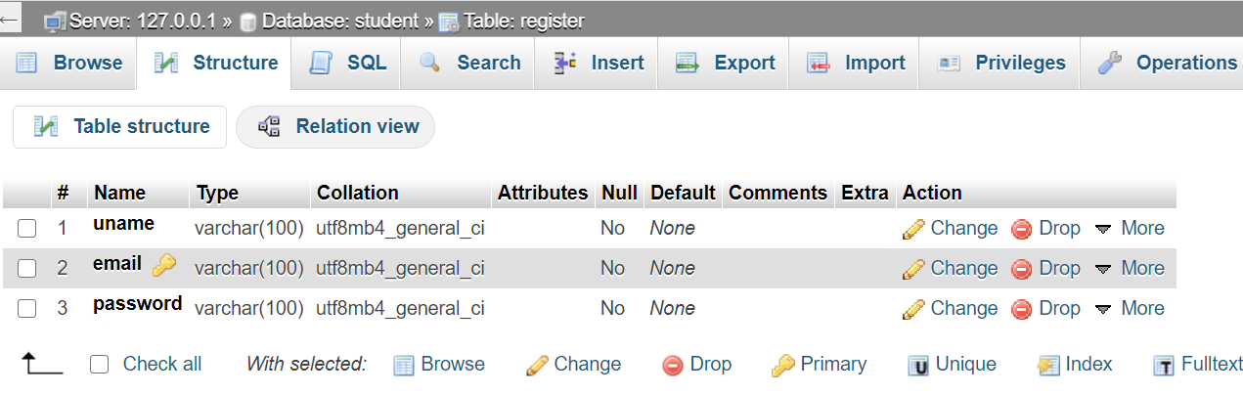

**Table3:**

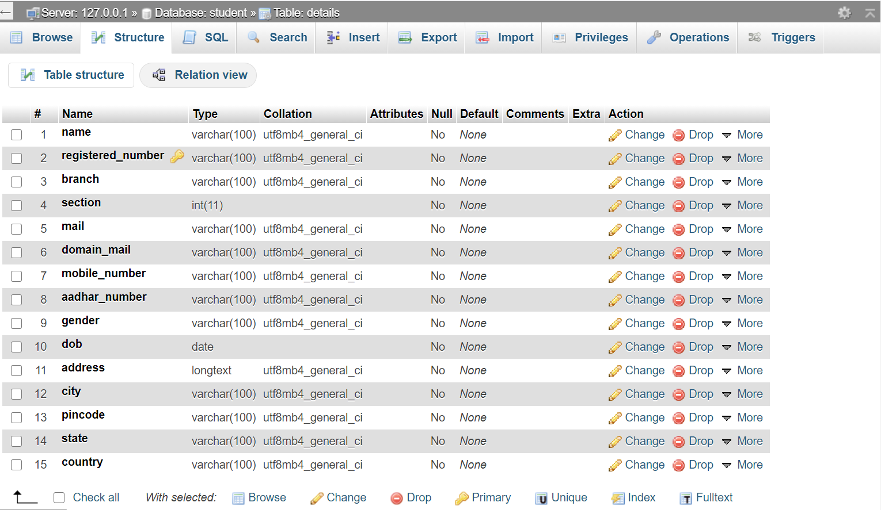

**Table4:**

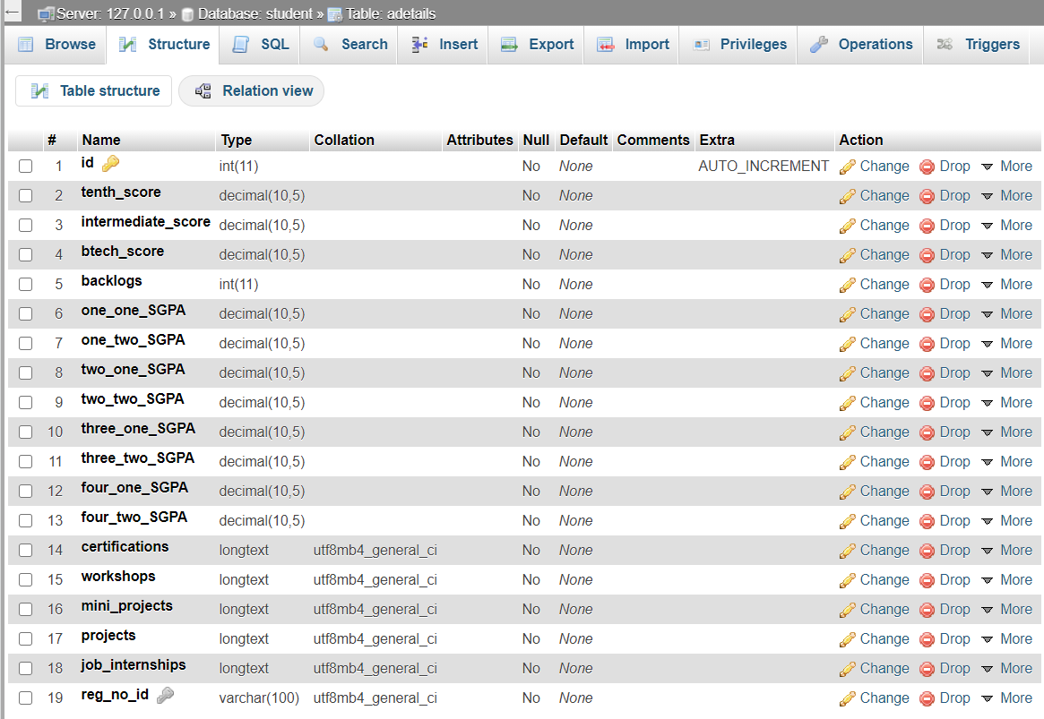

**Table5:**

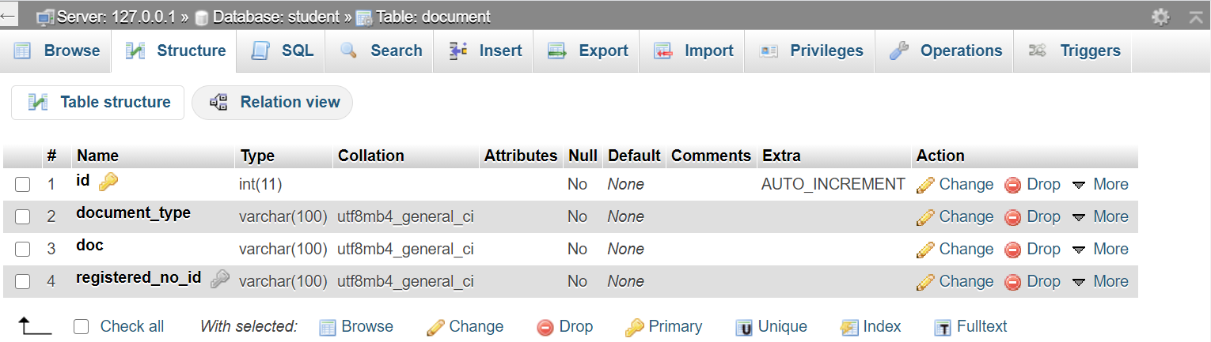

**CODE:**

# **settings.py:**

**# Database**

**# https://docs.djangoproject.com/en/3.0/ref/settings/#databases**

**DATABASES = {**

**'default': {**

**'ENGINE': 'django.db.backends.mysql',**

**'NAME': 'student',**

**'USER':'root',**

**'PASSWORD':'',**

**'HOST':'localhost',**

**'PORT':'3306',**

**'OPTIONS':{**

**'init_command':"SET sql_mode='STRICT_TRANS_TABLES'"**

**}**

**}**

**}**

**# Static files (CSS, JavaScript, Images)**

**# https://docs.djangoproject.com/en/3.0/howto/static-files/**

**STATIC_URL = '/static/'**

**STATICFILES_DIRS=[**

**os.path.join(BASE_DIR,'static'),**

**]**

**MEDIA_ROOT=os.path.join(BASE_DIR,'media')**

**MEDIA_URL='/media/'**

**#email settings**

**EMAIL_BACKEND='django.core.mail.backends.smtp.EmailBackend'**

**EMAIL_USE_TLS=True**

**EMAIL_HOST="smtp.gmail.com"**

**EMAIL_PORT=587**

**EMAIL_HOST_USER="ruchithareddy058@gmail.com"**

**EMAIL_HOST_PASSWORD='*********'**

# **urls.py:**

from django.contrib import admin

from django.urls import path

from django.contrib.auth import views as auth_views

from django.conf import settings

from student import views

from django.conf.urls.static import static

urlpatterns = [

path('admin/', admin.site.urls),

path('main/',views.main,name="main"),

path('main1/',views.main1,name="main1"),

path('home/',views.home,name="home"),

path('login/',views.login,name="login"),

path('login1/',views.login1,name="login1"),

path('uregister/',views.uregister,name="uregister"),

path('facregister/',views.facregister,name="facregister"),

path('password_reset/',auth_views.PasswordResetView.as_view(template_name="password_reset.html"),name='password_reset'),

path('password_reset_done/',auth_views.PasswordResetDoneView.as_view(template_name="password_reset_done.html"),

name='password_reset_done'),

path('password_reset_confirm/<uidb64>/<token>/',auth_views.PasswordResetConfirmView.as_view(template_name="password_reset_confirm.html"),

name='password_reset_confirm'),

path('password_reset_complete/',auth_views.PasswordResetCompleteView.as_view(template_name="password_reset_complete.html"),

name='password_reset_complete'),

path('dashboardz/',views.dashboardz,name="dashboardz"),

path('dashboard/',views.dashboard,name="dashboard"),

path('search/',views.search,name="search"),

path('dashboard_1/<str:r>',views.dashboard_1,name="dashboard_1"),

path('dashboard_2/<str:r>/',views.dashboard_2,name="dashboard_2"),

path('dashboard_3/<str:r>',views.dashboard_3,name="dashboard_3"),

path('dashboard0/<str:u>',views.dashboard0,name="dashboard0"),

path('dashboard1/<str:s>',views.dashboard1,name="dashboard1"),

path('dashboard2/<str:s>',views.dashboard2,name="dashboard2"),

path('dashboard3/<str:s>',views.dashboard3,name="dashboard3"),

path('dashboard4/<str:r>',views.dashboard4,name="dashboard4"),

path('dashboard5/<str:r>',views.dashboard5,name="dashboard5"),

path('dashboard6/<str:r>',views.dashboard6,name="dashboard6"),

path('edit1/<str:r>',views.edit1,name="edit1"),

path('edit2/<str:r>',views.edit2,name="edit2"),

path('update1/<str:r>',views.update1,name="update1"),

path('update2/<str:r>',views.update2,name="update2"),

path('delete/<str:r>/<str:d>',views.delete,name="delete")

]

if settings.DEBUG:

urlpatterns+=static(settings.STATIC_URL,document_root=settings.STATIC_ROOT)

urlpatterns+=static(settings.MEDIA_URL,document_root=settings.MEDIA_ROOT)

# **Views.py:**

**from django.shortcuts import render,redirect**

**from django.contrib import messages**

**from django.http import HttpResponse**

**from django.contrib.auth import authenticate**

**from django.contrib.auth.models import User,auth**

**from student.models import studregister,register,details,adetails,Document**

**# Create your views here.**

**def home(request):**

**return render(request,'home.html')**

**def login(request):**

**if request.COOKIES.get("cid1"):**

**return render(request,"login.html",{'cookie1':request.COOKIES['cid1'],**

**'cookie2':request.COOKIES['cid2']})**

**return render(request,"login.html")**

**def login1(request):**

**if request.COOKIES.get("cid3"):**

**return render(request,"login1.html",{'cookie3':request.COOKIES['cid3'],**

**'cookie4':request.COOKIES['cid4']})**

**return render(request,"login1.html")**

**def uregister(request):**

**if request.method=='POST':**

**uname=request.POST['uname']**

**email=request.POST['email']**

**password=request.POST['password']**

**user=User.objects.create_user(username=uname,password=password,email=email)**

**user.save()**

**data=studregister(uname=uname,email=email,password=password)**

**data.save()**

**messages.success(request,"Registration Successful!!!")**

**return render(request,'uregister.html')**

**else:**

**return render(request,'uregister.html')**

**def facregister(request):**

**if request.method=='POST':**

**uname=request.POST['uname']**

**email=request.POST['email']**

**password=request.POST['password']**

**user=User.objects.create_user(username=uname,password=password,email=email)**

**user.save()**

**data=register(uname=uname,email=email,password=password)**

**data.save()**

**messages.success(request,"Registration Successful!!!")**

**return render(request,'facregister.html')**

**else:**

**return render(request,'facregister.html')**

**def main(request):**

**if request.method=='POST':**

**uname=request.POST['uname']**

**password=request.POST['password']**

**user=authenticate(request,username=uname,password=password)**

**if user is not None:**

**if user.is_active:**

**if request.POST.get("remember"):**

**response=HttpResponse("<br/><br/><br/><br/><br/><br/><br/><br/><br/><br/><br/><br/><br/><br/><center><b>Your username and password will be remembered!!!<br/></br>Go back and uncheck remember me and login.")**

**response.set_cookie('cid1',request.POST["uname"])**

**response.set_cookie('cid2',request.POST["password"])**

**return response**

**p=studregister.objects.get(uname=uname)**

**p.password=password**

**p.save()**

**return render(request,'dashboard0.html',{'u':uname})**

**else:**

**messages.info(request,"Invalid username/password!")**

**return render(request,'login.html')**

**else:**

**messages.info(request,"Invalid username/password!")**

**return render(request,'login.html')**

**messages.info(request,"Invalid username/password!")**

**return render(request,'login.html')**

**def main1(request):**

**if request.method=='POST':**

**uname=request.POST['uname']**

**password=request.POST['password']**

**user=authenticate(request,username=uname,password=password)**

**if user is not None:**

**if user.is_active:**

**if request.POST.get("remember"):**

**response=HttpResponse("<br/><br/><br/><br/><br/><br/><br/><br/><br/><br/><br/><br/><br/><br/><center><b>Your username and password will be remembered!!!<br/></br>Go back and uncheck remember me and login.")**

**response.set_cookie('cid3',request.POST["uname"])**

**response.set_cookie('cid4',request.POST["password"])**

**return response**

**p=register.objects.get(uname=uname)**

**p.password=password**

**p.save()**

**return render(request,'dashboardz.html',{'u':uname})**

**else:**

**messages.info(request,"Invalid username/password!")**

**return render(request,'login1.html')**

**else:**

**messages.info(request,"Invalid username/password!")**

**return render(request,'login1.html')**

**messages.info(request,"Invalid username/password!")**

**return render(request,'login1.html')**

**def dashboard1(request,s):**

**if request.method=='POST':**

**name=request.POST['name']**

**registered_number=request.POST['registered_number']**

**branch=request.POST['branch']**

**section=request.POST['section']**

**mail=request.POST['mail']**

**domain_mail=request.POST['domain_mail']**

**mobile_number=request.POST['mobile_number']**

**aadhar_number=request.POST['aadhar_number']**

**gender=request.POST['gender'],**

**dob=request.POST['dob']**

**address=request.POST['address']**

**city=request.POST['city']**

**pincode=request.POST['pincode']**

**state=request.POST['state']**

**country=request.POST['country']**

**detail=details(name=name,registered_number=registered_number,branch=branch,section=section,**

**mail=mail,domain_mail=domain_mail,mobile_number=mobile_number,aadhar_number=aadhar_number,**

**gender=gender,dob=dob,address=address,city=city,pincode=pincode,state=state,country=country)**

**detail.save()**

**messages.info(request,"Details uploaded successfully!")**

**return render(request,'dashboard1.html',{'s':s})**

**else:**

**return render(request,'dashboard1.html',{'s':s})**

**def dashboard(request):**

**d=adetails.objects.all().order_by('reg_no')**

**return render(request,'dashboard.html',{'d':d})**

**def search(request):**

**q=request.GET.get('search')**

**d=adetails.objects.filter(reg_no__registered_number__contains=q)**

**if d:**

**return render(request,'dashboard.html',{'d':d})**

**d=adetails.objects.filter(reg_no__name__contains=q)**

**if d:**

**return render(request,'dashboard.html',{'d':d})**

**d=adetails.objects.all()**

**return render(request,'dashboard.html',{'d':d})**

**def dashboard_1(request,r):**

**s=details.objects.get(registered_number=r)**

**return render(request,'dashboard_1.html',{'s':s})**

**def dashboard_2(request,r):**

**s=adetails.objects.get(reg_no=r)**

**return render(request,'dashboard_2.html',{'s':s})**

**def dashboard_3(request,r):**

**s=Document.objects.filter(registered_no=r)**

**p=details.objects.get(registered_number=r)**

**return render(request,'dashboard_3.html',{'s':s,'p':p})**

**def dashboardz(request):**

**return render(request,'dashboardz.html')**

**def dashboard0(request,u):**

**return render(request,'dashboard0.html',{'u':u})**

**def dashboard2(request,s):**

**data1=details.objects.all()**

**if request.method=='POST':**

**reg_no=request.POST['reg_no']**

**tenth_score=request.POST['tenth_score']**

**intermediate_score=request.POST['intermediate_score']**

**btech_score=request.POST['btech_score']**

**backlogs=request.POST['backlogs']**

**one_one_SGPA=request.POST['one_one_SGPA']**

**one_two_SGPA=request.POST['one_two_SGPA']**

**two_one_SGPA=request.POST['two_one_SGPA']**

**two_two_SGPA=request.POST['two_two_SGPA']**

**three_one_SGPA=request.POST['three_one_SGPA']**

**three_two_SGPA=request.POST['three_two_SGPA']**

**four_one_SGPA=request.POST['four_one_SGPA']**

**four_two_SGPA=request.POST['four_two_SGPA']**

**certifications=request.POST['certifications']**

**workshops=request.POST['workshops']**

**mini_projects=request.POST['mini_projects']**

**projects=request.POST['projects']**

**job_internships=request.POST['job_internships']**

**rno=details.objects.get(registered_number=reg_no)**

**data=adetails(reg_no=rno,tenth_score=tenth_score,intermediate_score=intermediate_score,btech_score=btech_score,**

**backlogs=backlogs,one_one_SGPA=one_one_SGPA,one_two_SGPA=one_two_SGPA,**

**two_one_SGPA=two_one_SGPA,two_two_SGPA=two_two_SGPA,three_one_SGPA=three_one_SGPA,**

**three_two_SGPA=three_two_SGPA,four_one_SGPA=four_one_SGPA,four_two_SGPA=four_two_SGPA,**

**workshops=workshops,certifications=certifications,mini_projects=mini_projects,**

**projects=projects,job_internships=job_internships)**

**data.save()**

**messages.success(request,"Details uploaded successfully!")**

**return render(request,'dashboard2.html',{'data1':data1,'s':s})**

**return render(request,'dashboard2.html',{'data1':data1,'s':s})**

**def dashboard3(request,s):**

**data2=details.objects.all()**

**if request.method=='POST':**

**registered_no=request.POST['registered_no']**

**document_type=request.POST['document_type']**

**doc=request.FILES['doc']**

**r=details.objects.get(registered_number=registered_no)**

**upload=Document(registered_no=r,document_type=document_type,doc=doc)**

**upload.save()**

**messages.info(request,"Document uploaded successfully!")**

**return render(request,'dashboard3.html',{'data2':data2,'s':s})**

**return render(request,'dashboard3.html',{'data2':data2,'s':s})**

**def dashboard4(request,r):**

**try:**

**s=details.objects.get(registered_number=r)**

**if s:**

**return render(request,'dashboard4.html',{'s':s})**

**return render(request,'default.html',{'r':r})**

**except Exception:**

**return render(request,'default.html',{'r':r})**

**def dashboard5(request,r):**

**try:**

**s=adetails.objects.get(reg_no=r)**

**if s:**

**return render(request,'dashboard5.html',{'s':s})**

**return render(request,'default.html',{'r':r})**

**except Exception:**

**return render(request,'default.html',{'r':r})**

**def dashboard6(request,r):**

**s=Document.objects.filter(registered_no=r)**

**u=details.objects.get(registered_number=r)**

**return render(request,'dashboard6.html',{'s':s,'u':u})**

**def edit1(request,r):**

**s=details.objects.get(registered_number=r)**

**return render(request,'edit1.html',{'s':s})**

**def edit2(request,r):**

**s=adetails.objects.get(reg_no=r)**

**return render(request,'edit2.html',{'s':s})**

**def edit3(request,r,d):**

**s=Document.objects.get(registered_no=r,document_type=d)**

**return render(request,'edit3.html',{'s':s})**

**def update1(request,r):**

**s=details.objects.get(registered_number=r)**

**if request.method=="POST":**

**n=request.POST['name']**

**reg=s.registered_number**

**b=request.POST['branch']**

**sec=request.POST['section']**

**ma=request.POST['mail']**

**d=request.POST['domain_mail']**

**mobile=request.POST['mobile_number']**

**aadhar=request.POST['aadhar_number']**

**g=request.POST['gender'],**

**dofb=request.POST['dob']**

**a=request.POST['address']**

**c=request.POST['city']**

**p=request.POST['pincode']**

**st=request.POST['state']**

**cou=request.POST['country']**

**s.name=n**

**s.registered_number=reg**

**s.branch=b**

**s.section=sec**

**s.mail=ma**

**s.domain_mail=d**

**s.mobile_number=mobile**

**s.aadhar_number=aadhar**

**s.gender=g**

**s.dob=dofb**

**s.address=a**

**s.city=c**

**s.pincode=p**

**s.state=st**

**s.country=cou**

**s.save()**

**return render(request,'dashboard4.html',{'s':s})**

**return render(request,'edit1.html',{'s':s})**

**def update2(request,r):**

**s=adetails.objects.get(reg_no=r)**

**if request.method=="POST":**

**rg=s.reg_no**

**tenth=request.POST['tenth_score']**

**inter=request.POST['intermediate_score']**

**btech=request.POST['btech_score']**

**b=request.POST['backlogs']**

**one_one=request.POST['one_one_SGPA']**

**one_two=request.POST['one_two_SGPA']**

**two_one=request.POST['two_one_SGPA']**

**two_two=request.POST['two_two_SGPA']**

**three_one=request.POST['three_one_SGPA']**

**three_two=request.POST['three_two_SGPA']**

**four_one=request.POST['four_one_SGPA']**

**four_two=request.POST['four_two_SGPA']**

**c=request.POST['certifications']**

**w=request.POST['workshops']**

**m=request.POST['mini_projects']**

**p=request.POST['projects']**

**j=request.POST['job_internships']**

**s.reg_no=rg**

**s.tenth_score=tenth**

**s.intermediate_score=inter**

**s.btech_score=btech**

**s.backlogs=b**

**s.one_one_SGPA=one_one**

**s.one_two_SGPA=one_two**

**s.two_one_SGPA=two_one**

**s.two_two_SGPA=two_two**

**s.three_one_SGPA=three_one**

**s.three_two_SGPA=three_two**

**s.four_one_SGPA=four_one**

**s.four_two_SGPA=four_two**

**s.certifications=c**

**s.workshops=w**

**s.mini_projects=m**

**s.projects=p**

**s.job_internships=j**

**s.save()**

**return render(request,'dashboard5.html',{'s':s})**

**return render(request,'edit2.html',{'s':s})**

**def delete(request,r,d):**

**if request.method == 'POST':**

**f= Document.objects.filter(registered_no=r,document_type=d)**

**f.delete()**

**s=Document.objects.filter(registered_no=r)**

**u=details.objects.get(registered_number=r)**

**return render(request,'dashboard6.html',{'s':s,'u':u})**

# **models.py:**

**from django.db import models**

**# Create your models here.**

**class studregister(models.Model):**

**uname=models.CharField(max_length=100)**

**email=models.CharField(max_length=100,primary_key=True)**

**password=models.CharField(max_length=100)**

**class Meta:**

**db_table="studregister"**

**class register(models.Model):**

**uname=models.CharField(max_length=100)**

**email=models.CharField(max_length=100,primary_key=True)**

**password=models.CharField(max_length=100)**

**class Meta:**

**db_table="register"**

**class details(models.Model):**

**name=models.CharField(max_length=100)**

**registered_number=models.CharField(max_length=100,primary_key=True)**

**branch=models.CharField(max_length=100)**

**section=models.IntegerField()**

**mail=models.CharField(max_length=100)**

**domain_mail=models.CharField(max_length=100)**

**mobile_number=models.CharField(max_length=100)**

**aadhar_number=models.CharField(max_length=100)**

**gender=models.CharField(max_length=100)**

**dob=models.DateField()**

**address=models.TextField(max_length=400)**

**city=models.CharField(max_length=100)**

**pincode=models.CharField(max_length=100)**

**state=models.CharField(max_length=100)**

**country=models.CharField(max_length=100)**

**class Meta:**

**db_table="details"**

**class adetails(models.Model):**

**reg_no=models.ForeignKey(details,on_delete=models.CASCADE)**

**tenth_score=models.DecimalField(max_digits=10, decimal_places=5)**

**intermediate_score=models.DecimalField(max_digits=10, decimal_places=5)**

**btech_score=models.DecimalField(max_digits=10, decimal_places=5)**

**backlogs=models.IntegerField()**

**one_one_SGPA=models.DecimalField(max_digits=10,decimal_places=5)**

**one_two_SGPA=models.DecimalField(max_digits=10, decimal_places=5)**

**two_one_SGPA=models.DecimalField(max_digits=10, decimal_places=5)**

**two_two_SGPA=models.DecimalField(max_digits=10, decimal_places=5)**

**three_one_SGPA=models.DecimalField(max_digits=10, decimal_places=5)**

**three_two_SGPA=models.DecimalField(max_digits=10, decimal_places=5)**

**four_one_SGPA=models.DecimalField(max_digits=10, decimal_places=5)**

**four_two_SGPA=models.DecimalField(max_digits=10, decimal_places=5)**

**certifications=models.TextField(max_length=400)**

**workshops=models.TextField(max_length=400)**

**mini_projects=models.TextField(max_length=400)**

**projects=models.TextField(max_length=400)**

**job_internships=models.TextField(max_length=400)**

**class Meta:**

**db_table="adetails"**

**class Document(models.Model):**

**registered_no=models.ForeignKey(details,on_delete=models.CASCADE)**

**document_type=models.CharField(max_length=100)**

**doc=models.FileField()**

**class Meta:**

**db_table="document"**

# 5.RESULTS:

# **:**



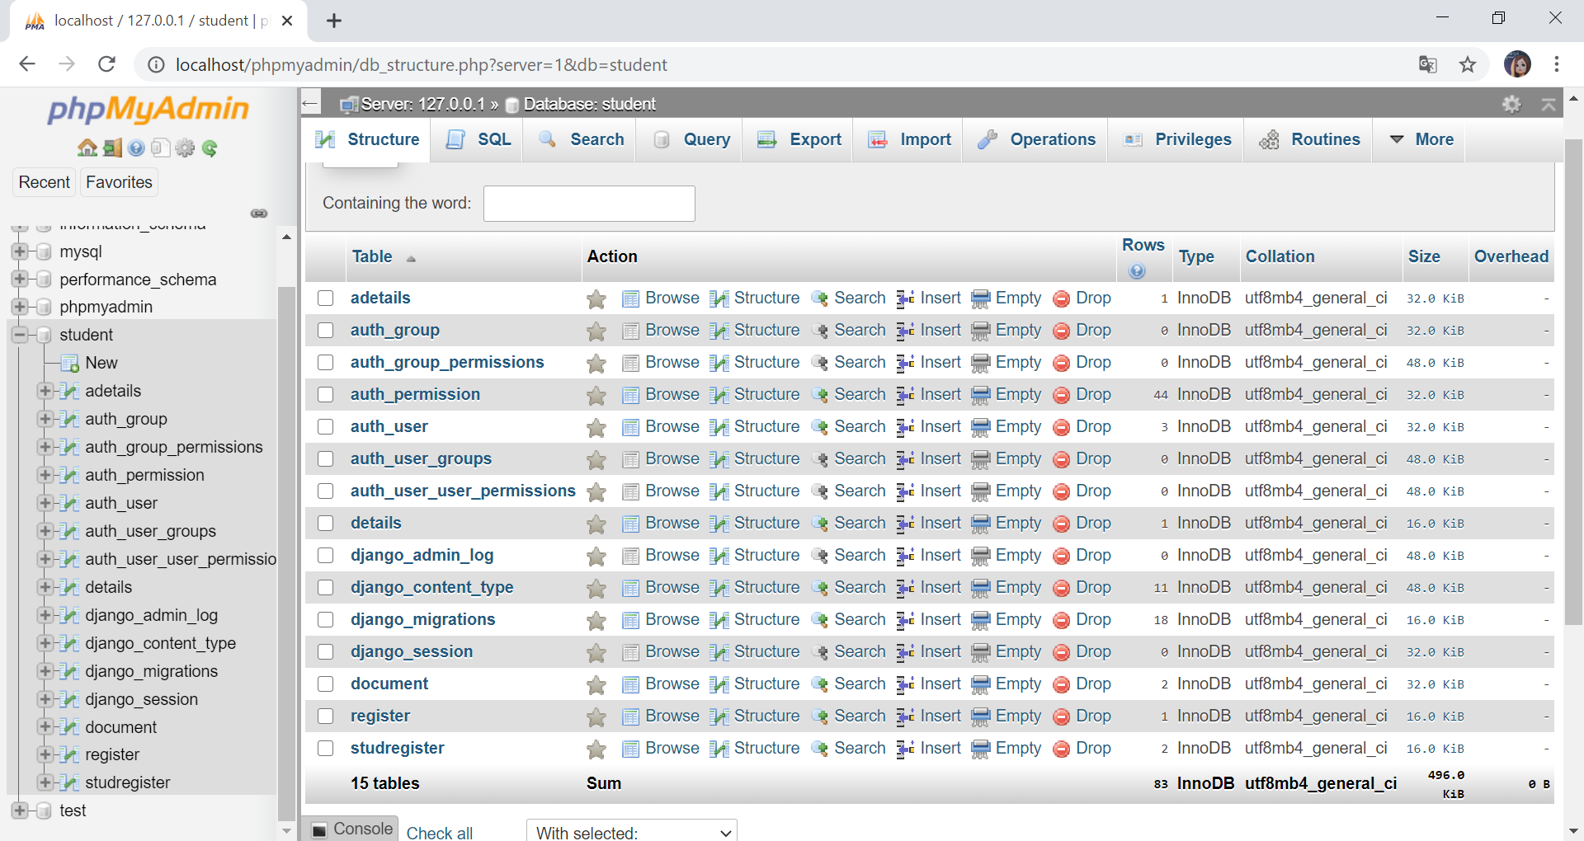

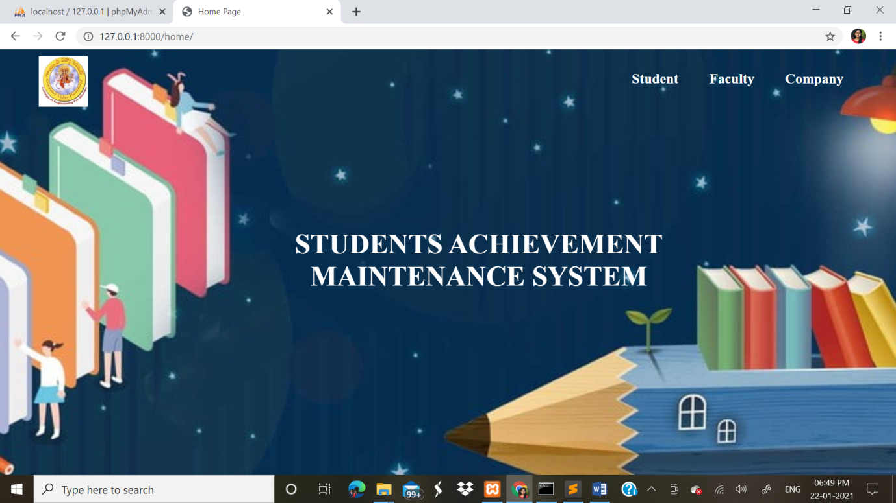

Fig1:home page

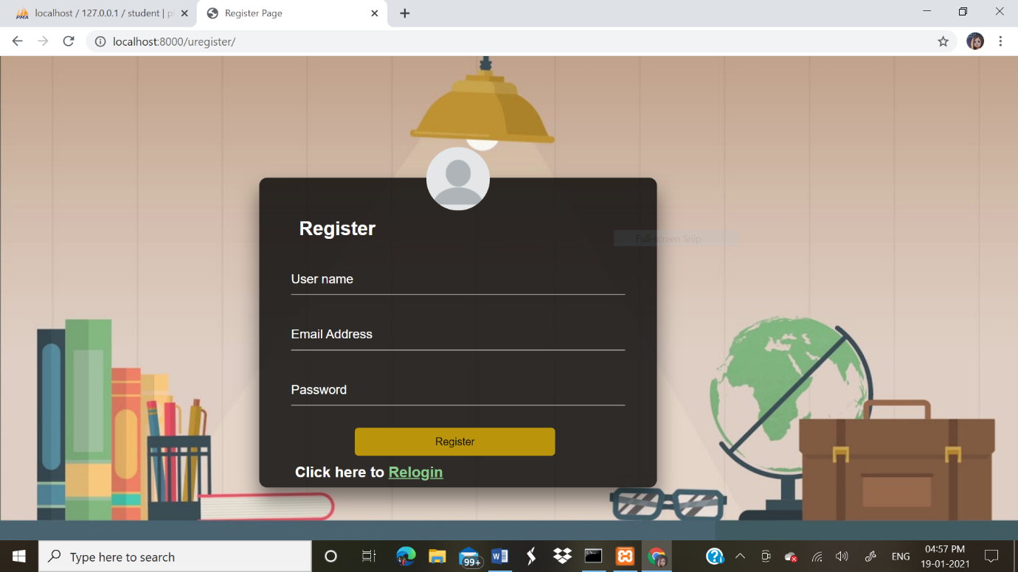

Fig2: Student registration page

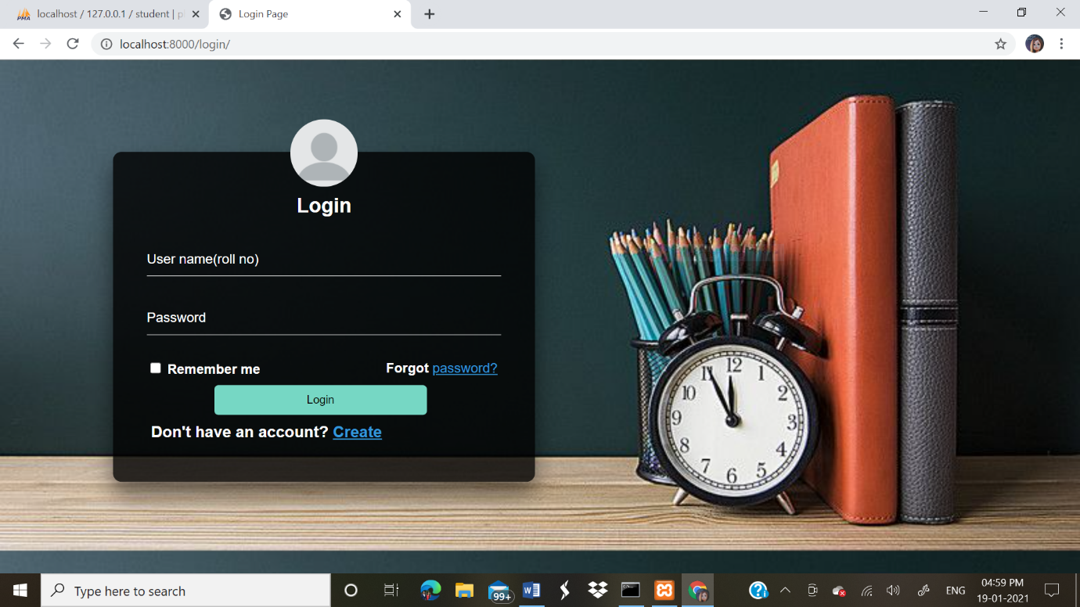

Fig3:Student login page

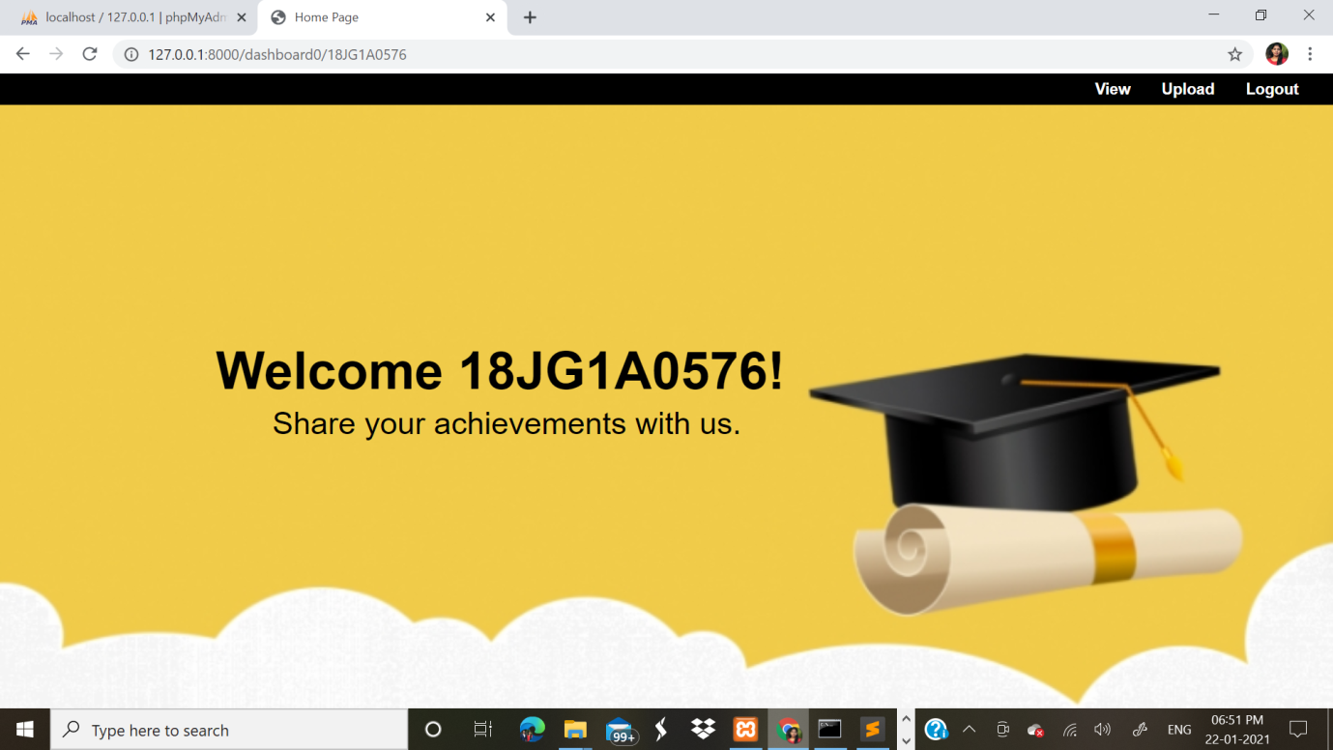

Fig4:Student dashboard

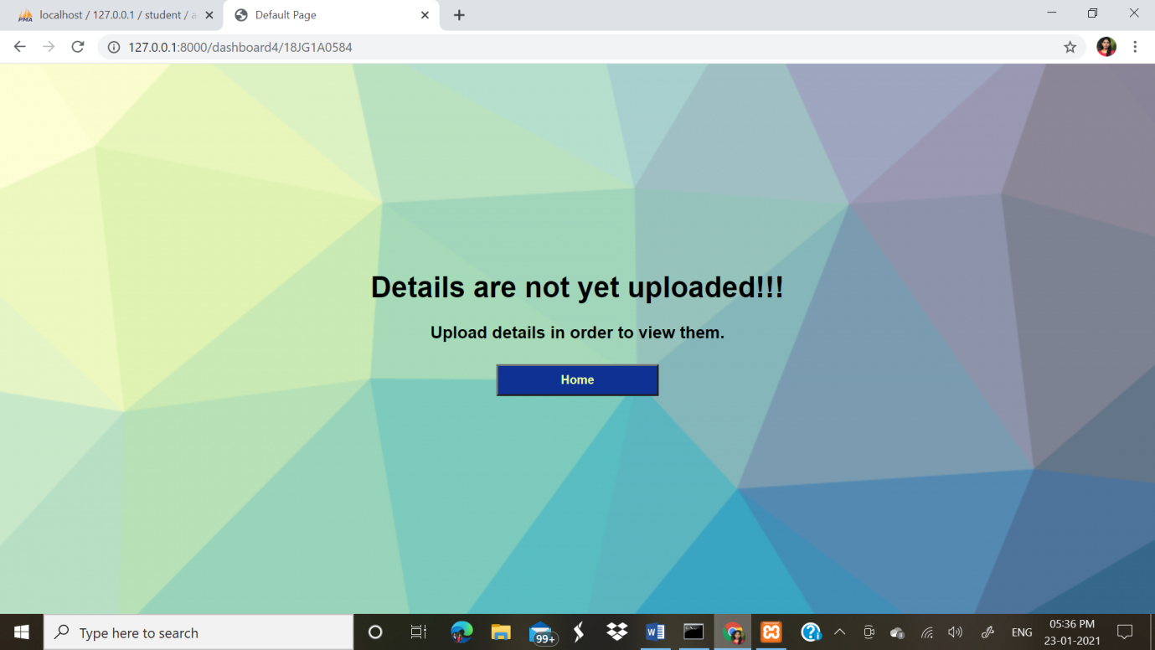

Fig5:Student View page(before uploading details)

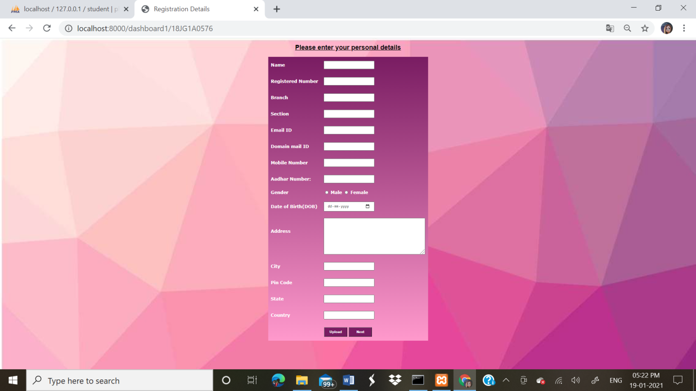

Fig6.1:Student personal details upload page

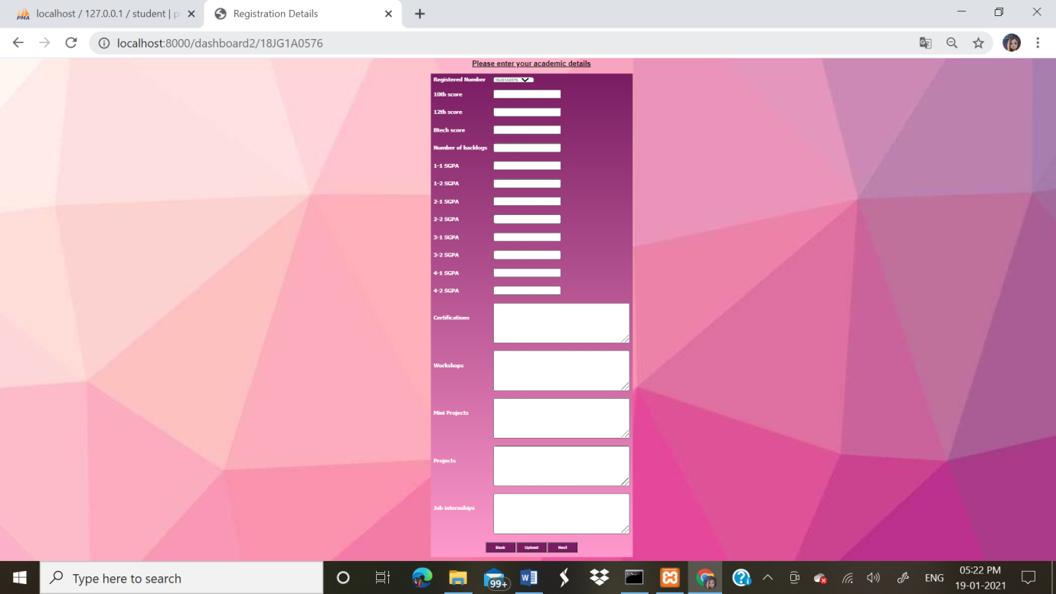

Fig6.2:Student academic details upload page

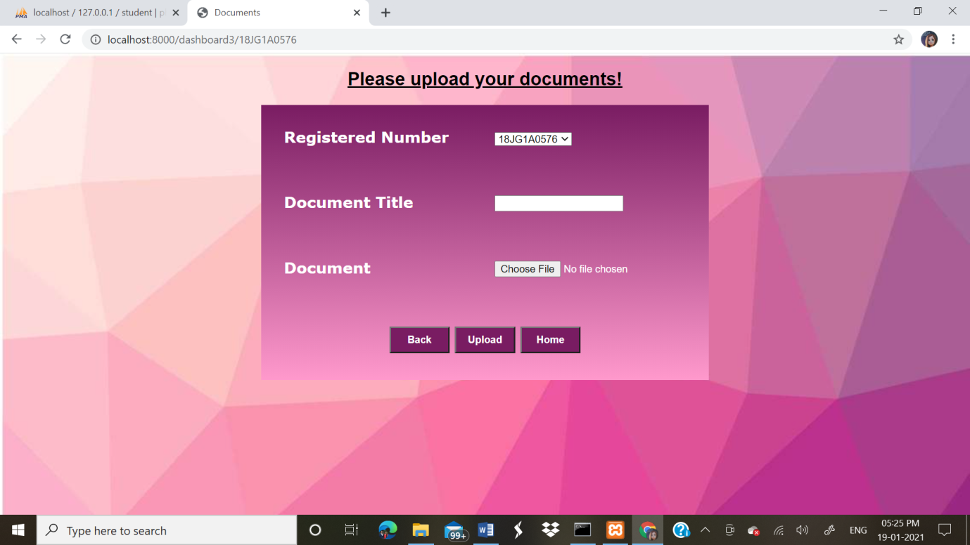

Fig6.3:Student documents upload page

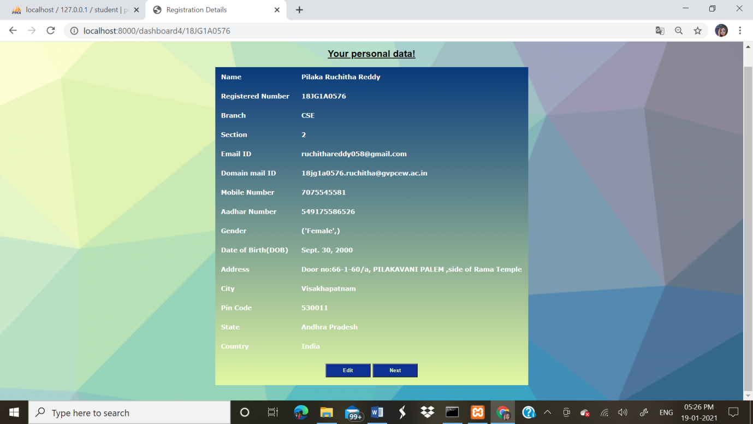

Fig7.1: Student personal details view page(after uploading details)

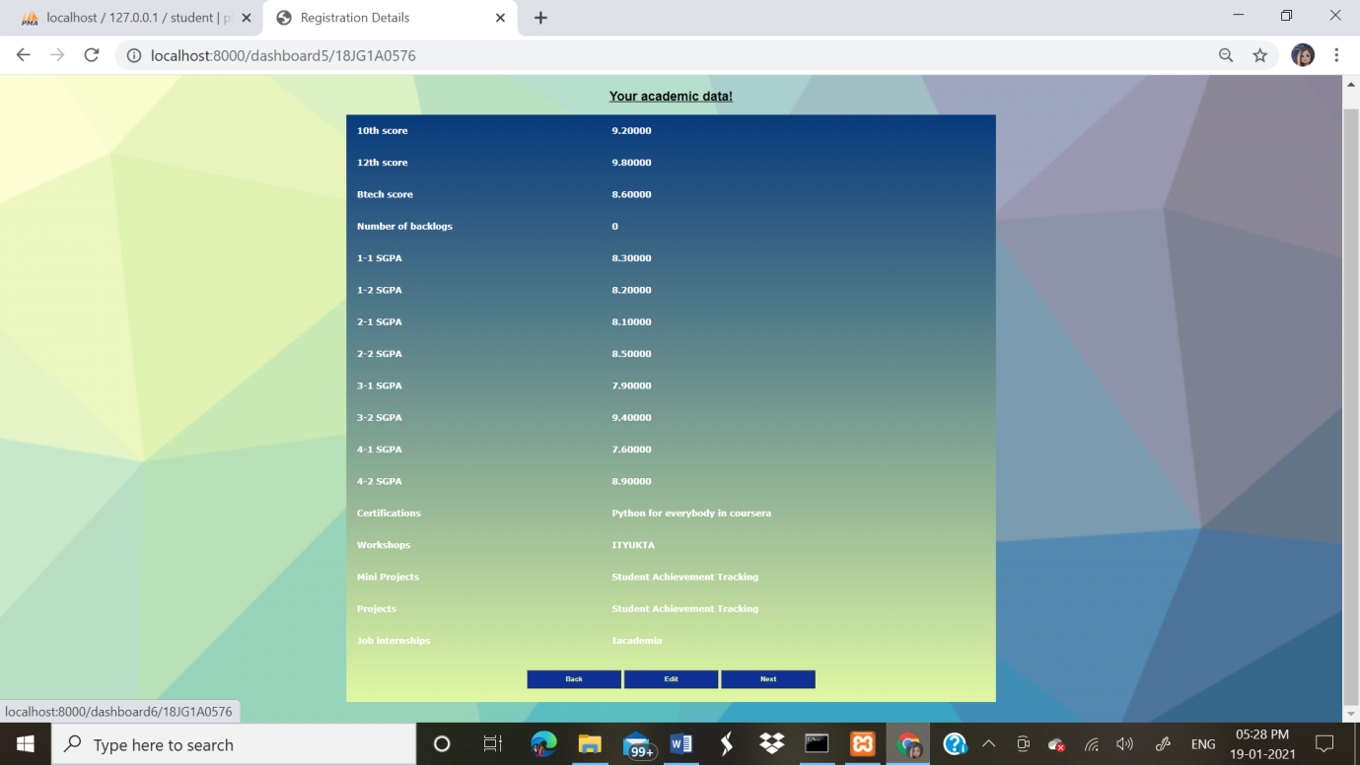

Fig7.2: Student academic details view page(after uploading details)

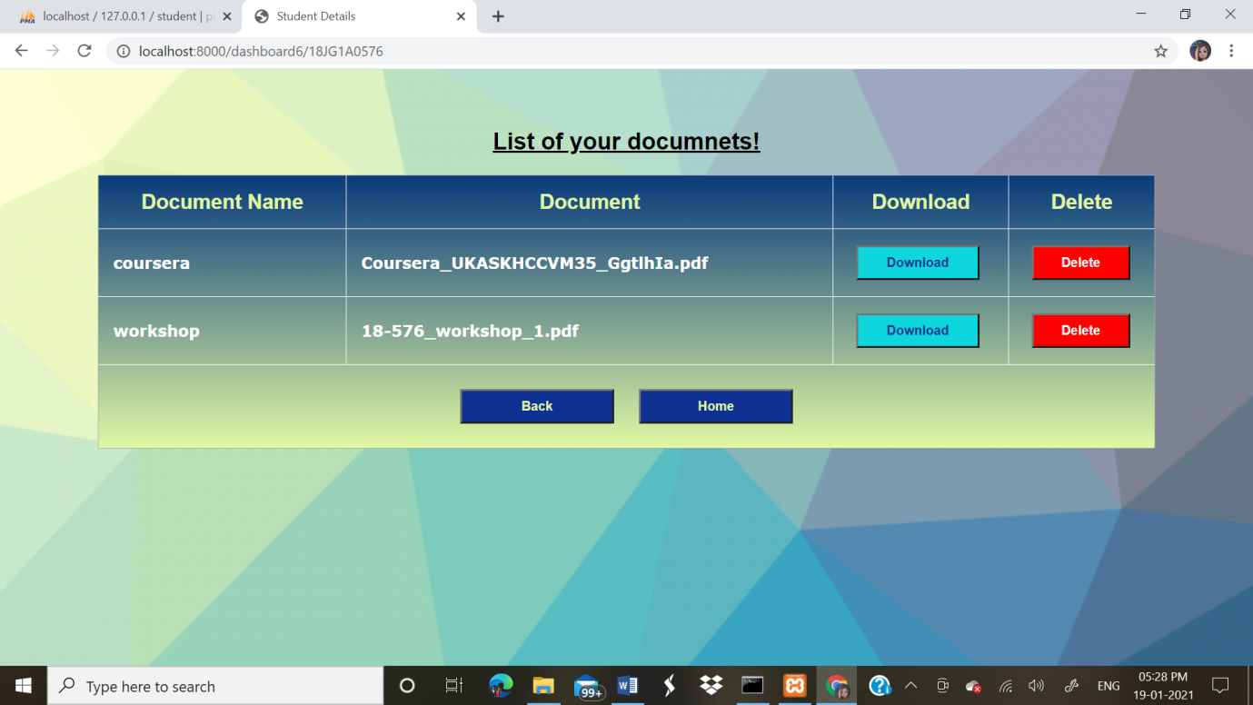

Fig7.3: Student documents view page(after uploading details)

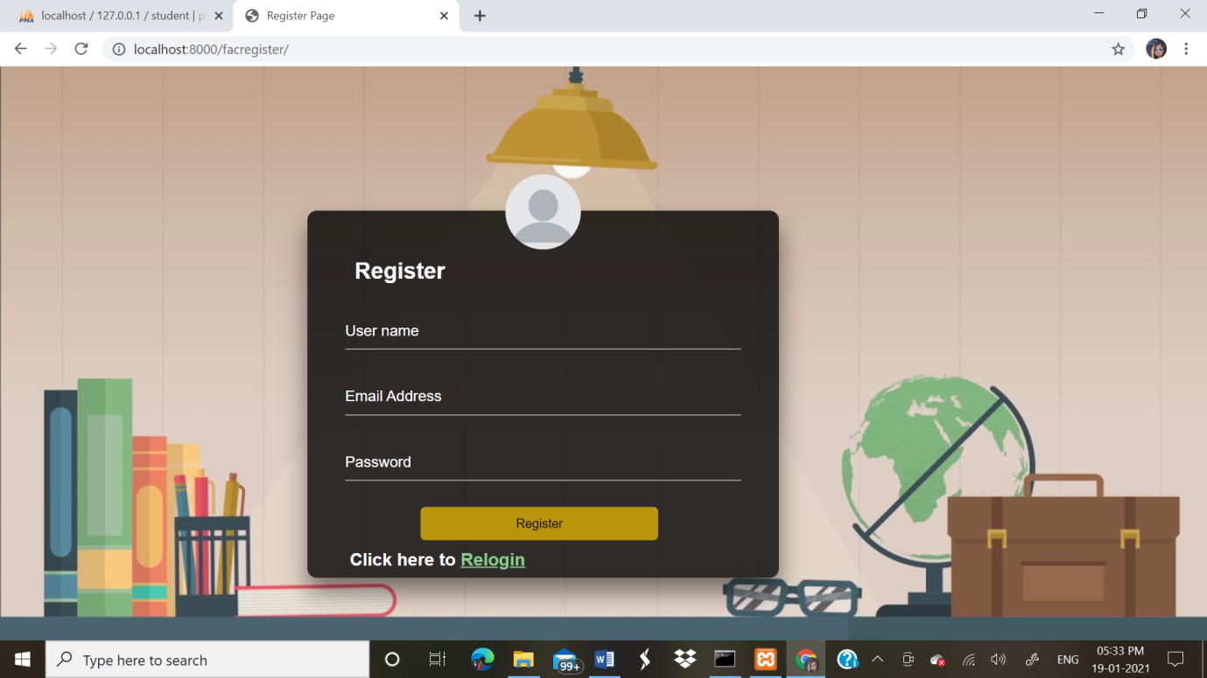

Fig9.Faculty & Company register page

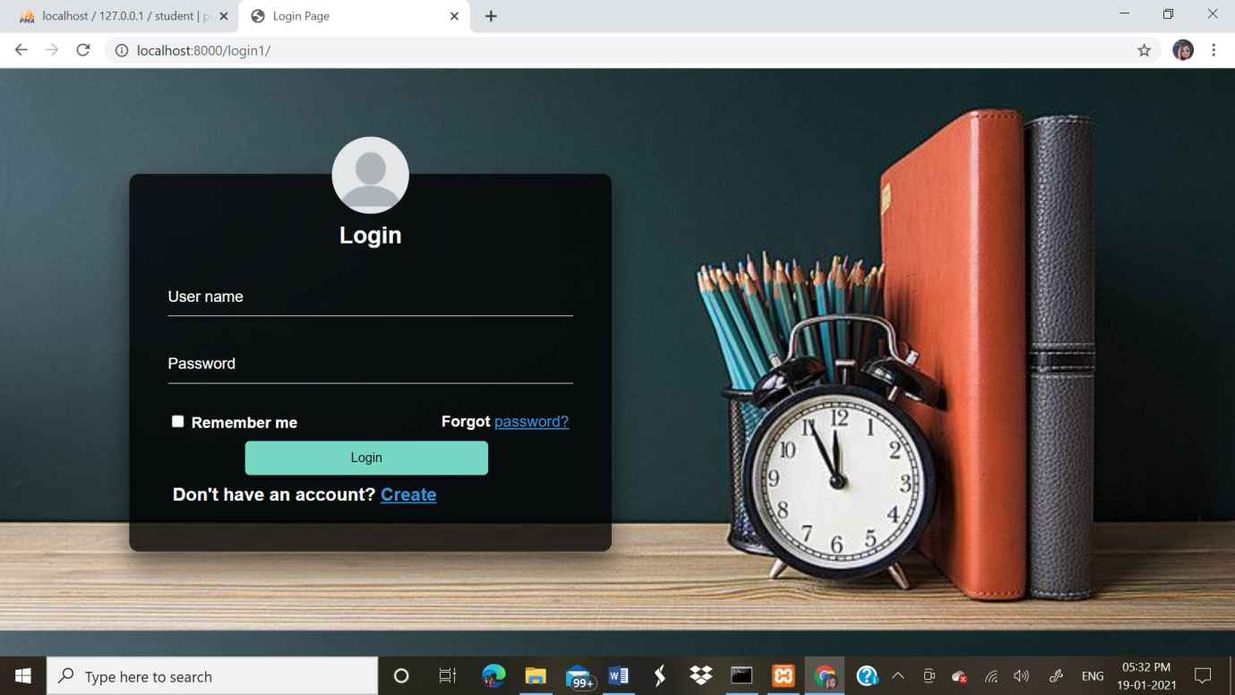

Fig9.Faculty & Company login page



Fig 10:Faculty or company dashboard page

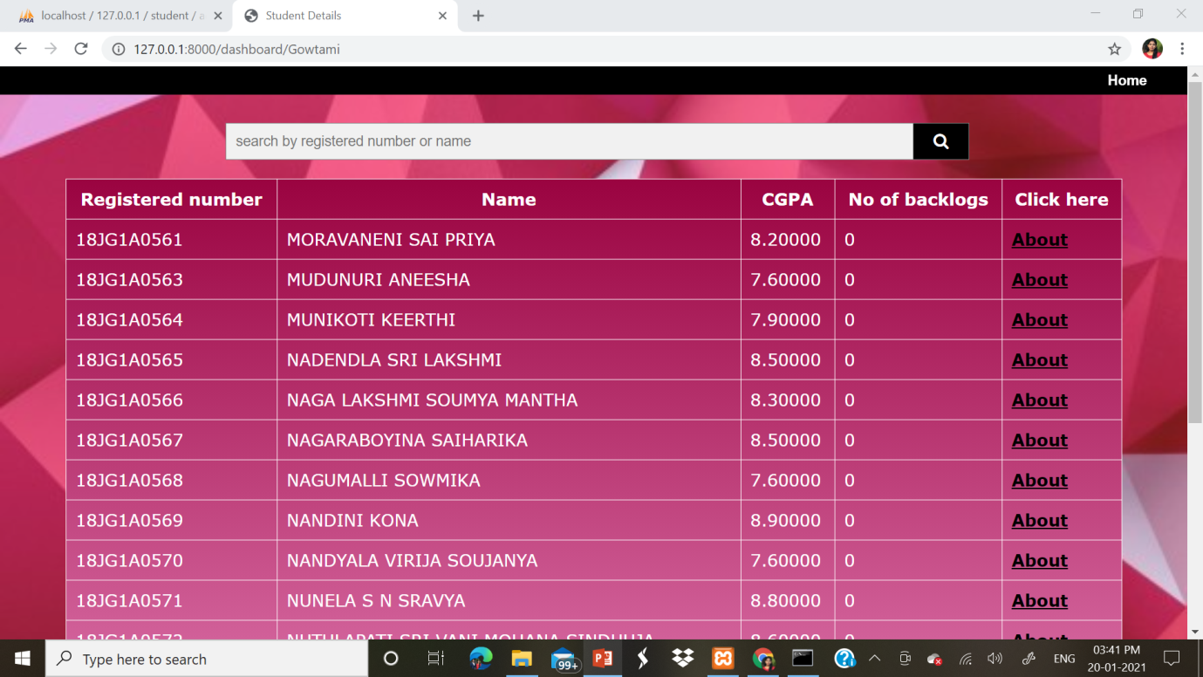

Fig 10:Faculty or Company view page

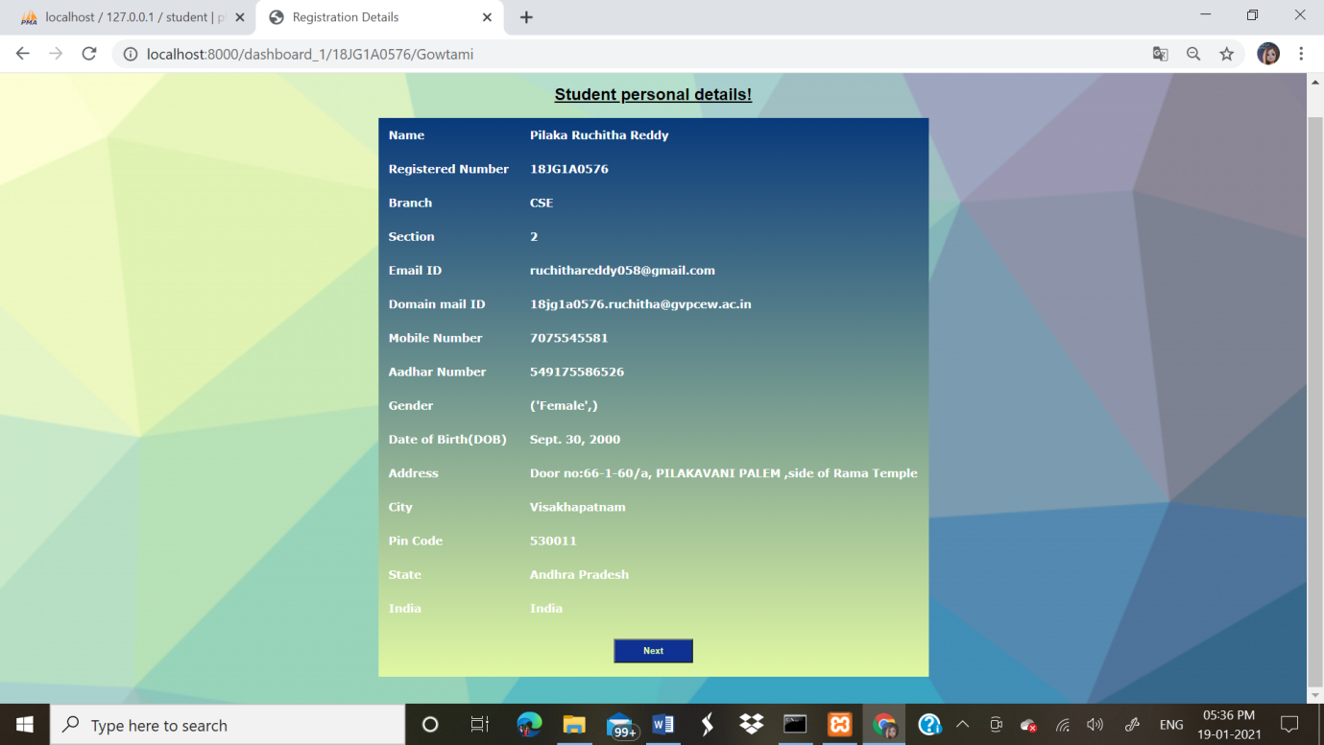

Fig11.1: Faculty or Company about page

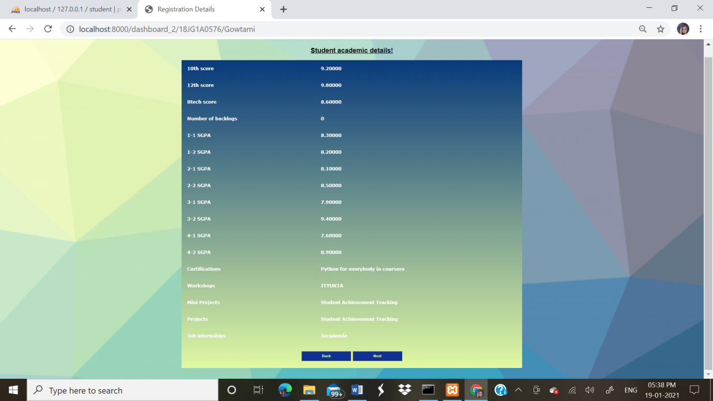

Fig11.2: Faculty or Company about page

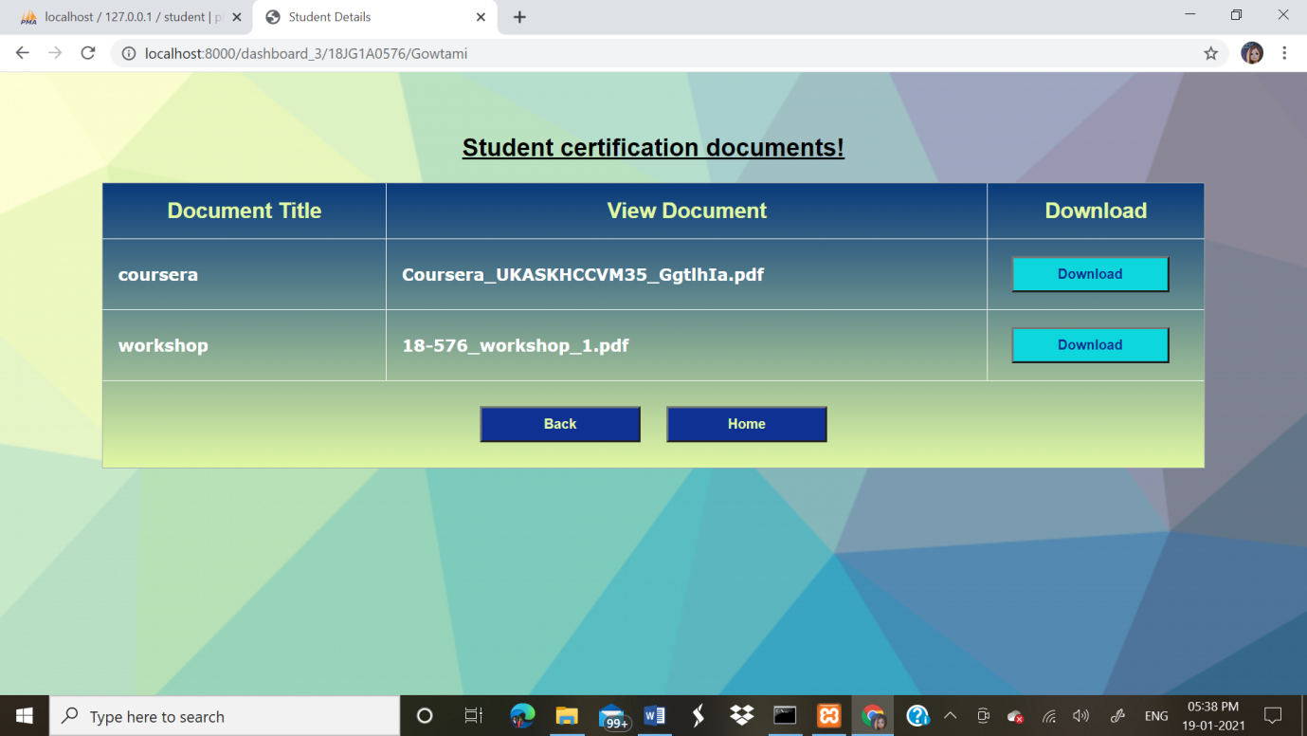

Fig11.3: Faculty or Company about page

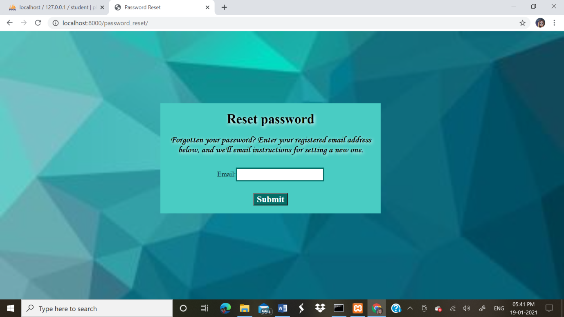

Fig12: Password reset page

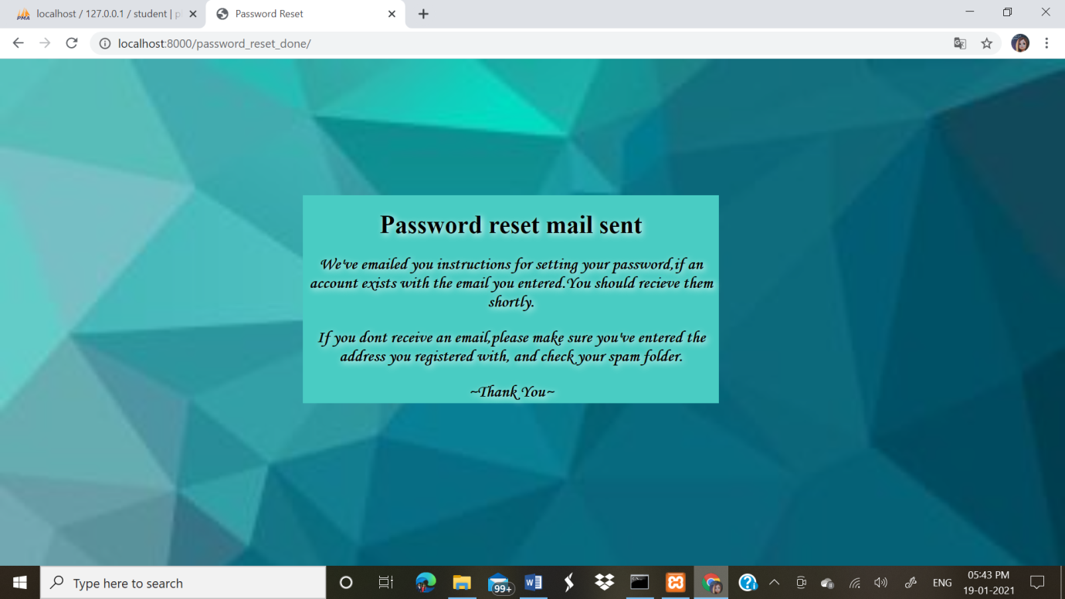

Fig13: Password reset mail sent page

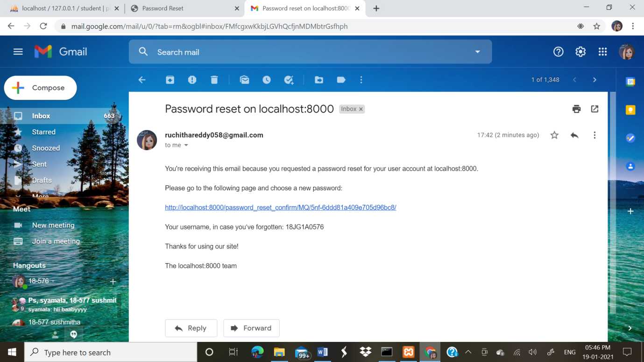

Fig14: Password reset mail received

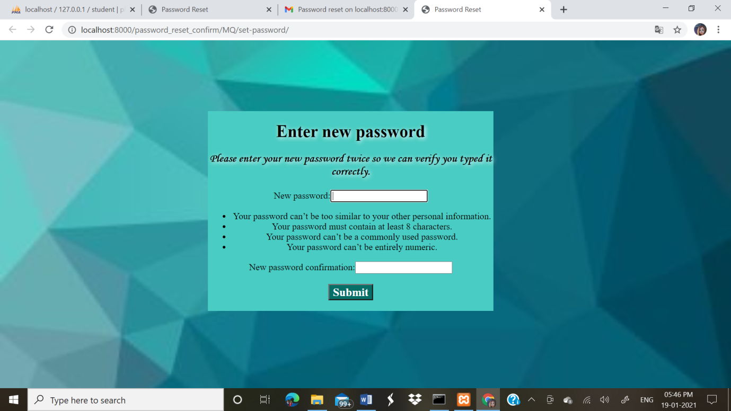

Fig14: New password reset page

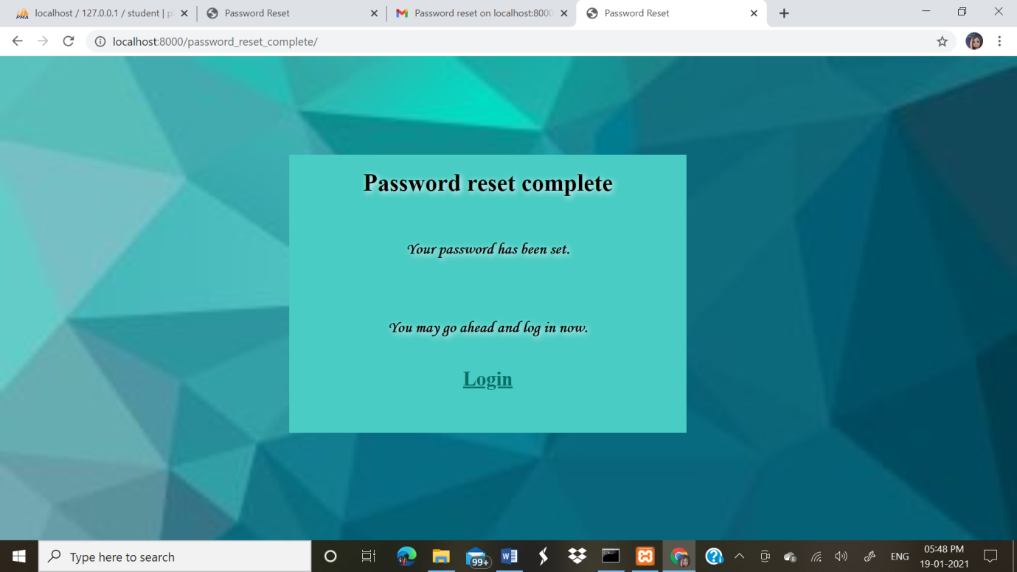

Fig14: Password reset complete page

# 5.Conclusion:

The existing system which needs a lot of manual effort inorder to collect the student data and to maintain proper records of it, and the company which needs to allocate time inorder to visit the campus and collect the students information, additionally the time required to filter students based on their performances during campus drives, is a time consuming and effort requiring process .All the problems related to this issue are resolved.

Now the student information is uploaded by the student self so the data will be more accurate and it also reduces the manual effort required by the organization inorder to collect the data.The data can be modified with an ease and there is no chance of data misplacement. The data can be accessed from anywhere and anytime as required which saves time.It also help us to easily track the progress and achievements of the student.

Thus, “the Students Achievement Maintenance System” proves to be an effective solution which makes tasks more easier.

# References:

<https://docs.djangoproject.com/en/3.1/topics/db/models/>

<https://www.w3schools.com/html/default.asp>

<https://www.w3schools.com/css/default.asp>

<https://www.javatpoint.com/creating-mysql-database-with-xampp>